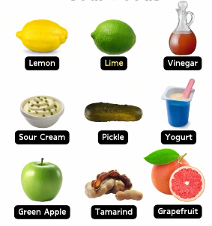
SOUR FOOD IMAGES

